**Exercise 1: Setting Up JUnit**

Scenario: You need to set up JUnit in your Java project to start writing unit tests.

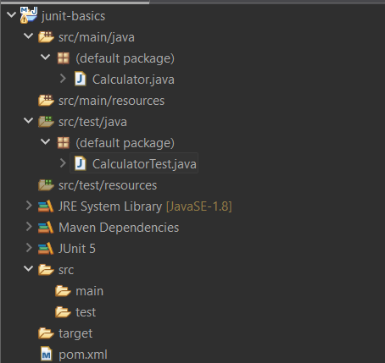

Calculator.java :

public class Calculator {

public int add(int a, int b) {

return a + b;

}

}

CalculatorTest.java :

import org.junit.Test;

import static org.junit.Assert.*;

public class CalculatorTest {

*@Test*

public void testAdd() {

Calculator calc = new Calculator();

*assertEquals*(5, calc.add(2, 3));

}

}

Output:

